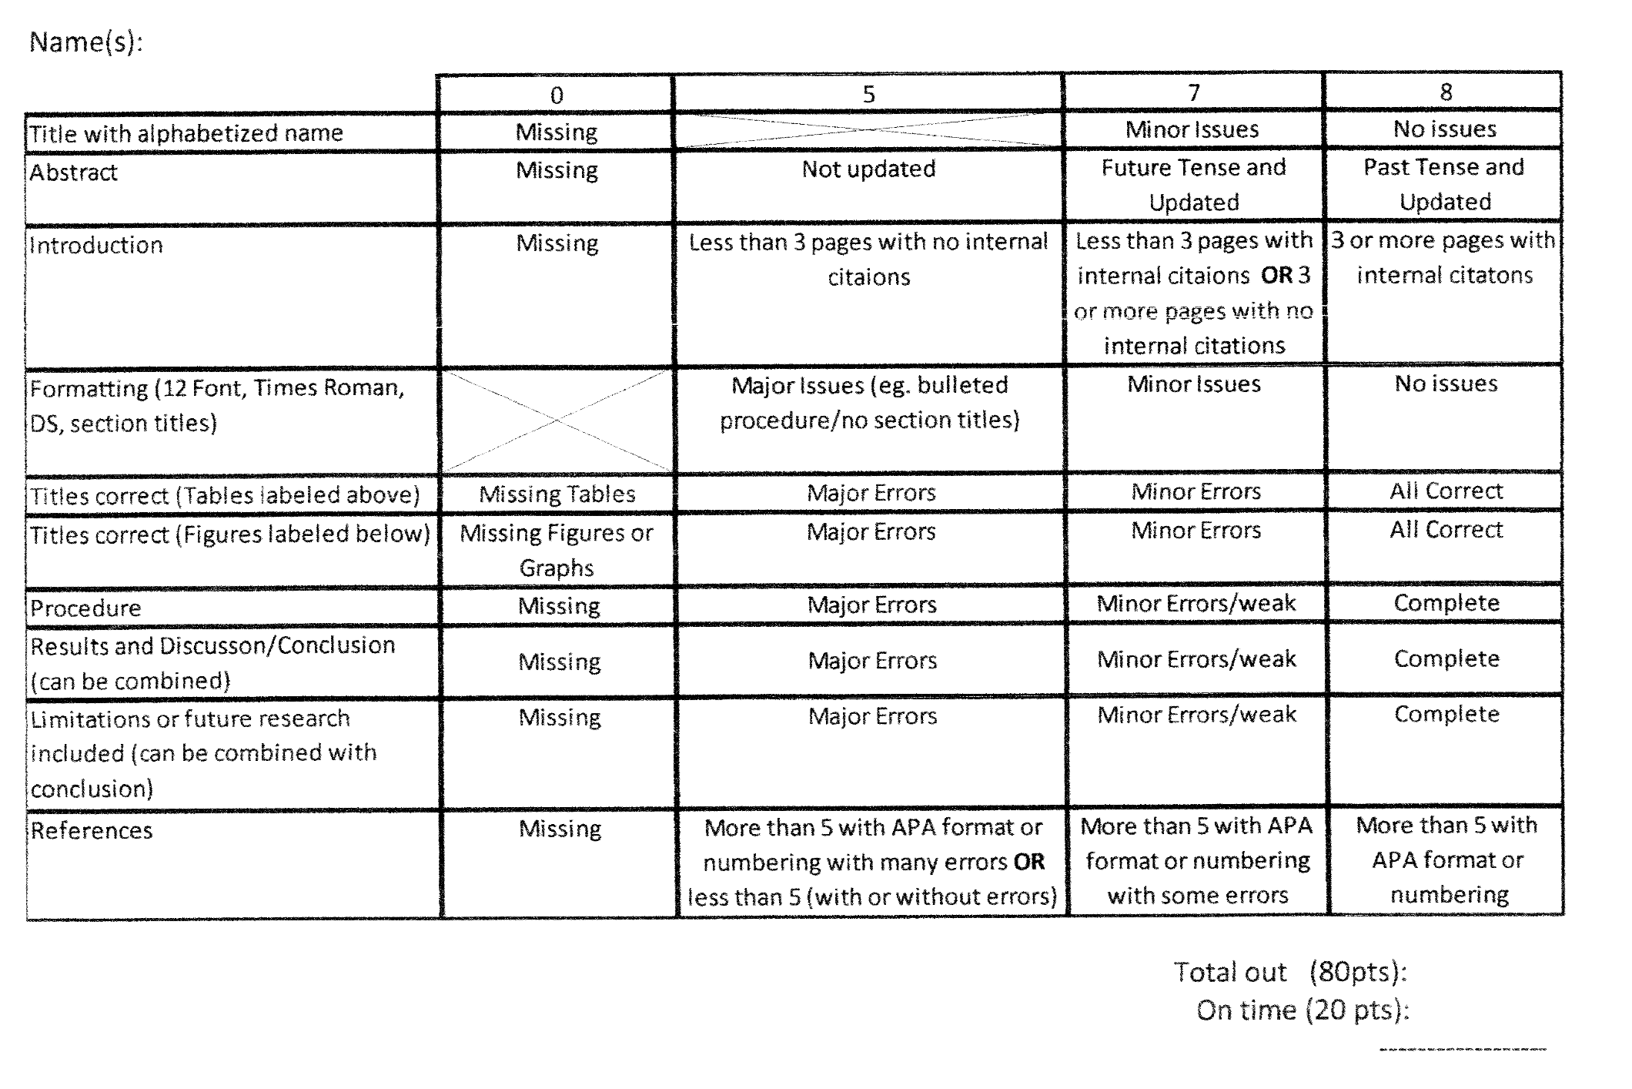

1.5 pages with internal citations

Less than 1.5 pages with internal citations **OR** 1.5 or more pages with no internal citations

Less than 1.5 pages with no internal citations

Needs to be 1.5 pages minimum